|  |  |  |
| --- | --- | --- |
|  | |  |
| Name: Muhammad Ali | Roll No: 21L-5463 | |
| Course: PDC | Section: 6J | |
| Date: 15-03-2024 | Document Name: A_02 | |

**Question 1:**

Let,

* N = Size of the array
* P = Number of processes
* block_size = Size of each block [1,n]

Note: these calculations are considering it acyclic distribution.

a) How many tasks/blocks will be there?

Ans: Number of tasks/blocks = P, since we are distributing the array across P processes

b) What will be the size of each block?

Ans: block_size = N / P.

c) If block number starts from zero then, to which process number the ith block will be assigned?

Ans: The ith block will be assigned to process number i (more precisely i%P).

d) Suppose array indexing starts from zero, what will be the starting index of the block assigned to ith process?

Ans: The starting index of the block assigned to the ith process = i * block_size.

e) Suppose array indexing starts from zero, what will be the end index of the block assigned to ith process? The end index of the block assigned to the ith process = (i + 1) * block_size -1.

Please note that if N is not divisible by P, the last block might be smaller than the others (to adjust incompatibility), and you may need to handle this case accordingly.

**Question 2:**

#include <stdio.h>

#include <stdlib.h>

#include <pthread.h>

#include <time.h>

#define MAX_THREADS 128

int m1, n1;

int **matrixA, **matrixB, **result;

pthread_mutex_t mutex;

void *multiply_row(void *arg) {

int row = *(int *)arg;

for (int col = 0; col < n1; col++) {

result[row][col] = 0;

for (int k = 0; k < m1; k++) {

result[row][col] += matrixA[row][k] * matrixB[k][col];

}

}

pthread_mutex_unlock(&mutex);

free(arg);

return NULL;

}

int main(int argc, char *argv[]) {

if (argc != 3) {

printf("Usage: %s <m1> <n1>\n", argv[0]);

exit(1);

}

m1 = atoi(argv[1]);

n1 = atoi(argv[2]);

matrixA = (int **)malloc(m1 * sizeof(int *));

for (int i = 0; i < m1; i++) {

matrixA[i] = (int *)malloc(n1 * sizeof(int));

}

matrixB = (int **)malloc(m1 * sizeof(int *));

for (int i = 0; i < m1; i++) {

matrixB[i] = (int *)malloc(n1 * sizeof(int));

}

result = (int **)malloc(m1 * sizeof(int *));

for (int i = 0; i < m1; i++) {

result[i] = (int *)malloc(n1 * sizeof(int));

}

srand(time(NULL));

for (int i = 0; i < m1; i++) {

for (int j = 0; j < n1; j++) {

matrixA[i][j] = rand() % 10;

matrixB[i][j] = rand() % 10;

}

}

pthread_t threads[MAX_THREADS];

pthread_mutex_init(&mutex, NULL);

// Create threads, assigning each row to a thread

for (int i = 0; i < m1; i++) {

int *row_arg = malloc(sizeof(int));

*row_arg = i;

int err = pthread_create(&threads[i], NULL, multiply_row, row_arg);

if (err != 0) {

perror("pthread_create");

exit(1);

}

}

for (int i = 0; i < m1; i++) {

pthread_join(threads[i], NULL);

}

pthread_mutex_destroy(&mutex);

printf("Matrix A:\n");

for (int i = 0; i < m1; i++) {

for (int j = 0; j < n1; j++) {

printf("%d ", matrixA[i][j]);

}

printf("\n");

}

printf("Matrix B:\n");

for (int i = 0; i < m1; i++) {

for (int j = 0; j < n1; j++) {

printf("%d ", matrixB[i][j]);

}

printf("\n");

}

printf("Resultant Matrix:\n");

for (int i = 0; i < m1; i++) {

for (int j = 0; j < n1; j++) {

printf("%d ", result[i][j]);

}

printf("\n");

}

for (int i = 0; i < m1; i++) {

free(matrixA[i]);

free(matrixB[i]);

free(result[i]);

}

free(matrixA);

free(matrixB);

free(result);

return 0;

}

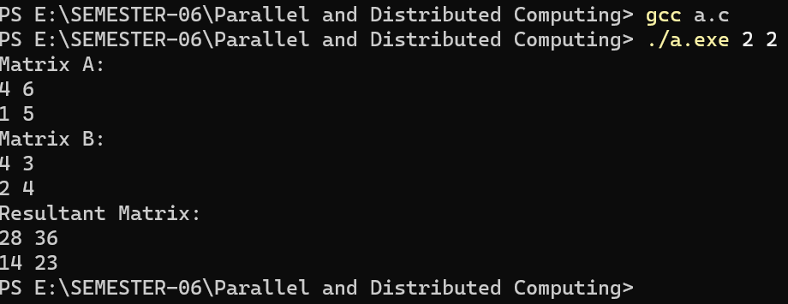

**Question 4:**

#include <stdio.h>

#include <stdlib.h>

#include <pthread.h>

#include <time.h>

#define MAX_THREADS 128

int m, n;

int matrix[MAX_THREADS][MAX_THREADS];

int matrix_addition = 0;

pthread_mutex_t mutex = PTHREAD_MUTEX_INITIALIZER; // Mutex for thread-safe access

void swap(int *a, int *b) {

int temp = *a;

*a = *b;

*b = temp;

}

int partition(int arr[], int low, int high) {

int pivot = arr[high];

int i = (low - 1);

for (int j = low; j <= high - 1; j++) {

if (arr[j] <= pivot) {

i++;

swap(&arr[i], &arr[j]);

}

}

swap(&arr[i + 1], &arr[high]);

return (i + 1);

}

void quickSort(int arr[], int low, int high) {

if (low < high) {

int pi = partition(arr, low, high);

quickSort(arr, low, pi - 1);

quickSort(arr, pi + 1, high);

}

}

void *sort_and_sum(void *arg) {

int thread_id = *((int *)arg);

int sum = 0;

if (thread_id < n && (m % 10) / 3 == 0) { // Sort columns (last digit 0, 1, or 2)

quickSort(matrix[thread_id], 0, m - 1);

for (int i = 0; i < m; i++) {

sum += matrix[i][thread_id];

}

} else if (thread_id < n && (m % 10) / 3 == 1) { // Sort columns (last digit 3, 4, or 5) - Descending

quickSort(matrix[thread_id], 0, m - 1);

for (int i = m - 1; i >= 0; i--) {

sum += matrix[i][thread_id];

}

} else if (thread_id < m && (m % 10) / 3 == 2) { // Sort rows (last digit 6 or 7)

quickSort(matrix[thread_id], 0, n - 1);

for (int i = 0; i < n; i++) {

sum += matrix[thread_id][i];

}

} else if (thread_id < m && (m % 10) / 3 == 3) { // Sort rows (last digit 8 or 9) - Descending

quickSort(matrix[thread_id], 0, n - 1);

for (int i = n - 1; i >= 0; i--) {

sum += matrix[thread_id][i];

}

}

pthread_mutex_lock(&mutex);

matrix_addition += sum;

pthread_mutex_unlock(&mutex);

free(arg);

return NULL;

}

int main() {

srand(time(NULL));

printf("Enter the dimensions of the matrix (m x n): ");

do {

scanf("%d %d", &m, &n);

if (m > MAX_THREADS || n > MAX_THREADS) {

printf("Error: Matrix dimensions exceed maximum thread limit (%d).\n", MAX_THREADS);

printf("Please enter valid dimensions (less than or equal to %d): ", MAX_THREADS);

}

} while (m > MAX_THREADS || n > MAX_THREADS);

printf("Enter your student ID: ");

int student_id;

scanf("%d", &student_id);

for (int i = 0; i < m; i++) {

for (int j = 0; j < n; j++) {

matrix[i][j] = rand() % 10;

}

}

printf("\nInput Matrix:\n");

for (int i = 0; i < m; i++) {

for (int j = 0; j < n; j++) {

printf("%d ", matrix[i][j]);

}

printf("\n");

}

int num_threads = (m % 10) / 3 < 2 ? n : m; // Determine thread count based on sort direction

pthread_t threads[num_threads];

int *thread_args[num_threads];

printf("1");

for (int i = 0; i < num_threads; i++) {

thread_args[i] = malloc(sizeof(int));

*thread_args[i] = i; // Pass thread ID as argument

int ret = pthread_create(&threads[i], NULL, sort_and_sum, thread_args[i]);

if (ret) {

fprintf(stderr, "Error: Failed to create thread %d\n", i);

return 1;

}

}

printf("\n 2");

for (int i = 0; i < num_threads; i++) {

pthread_join(threads[i], NULL);

}

printf("\n 3");

printf("\nOutput Matrix:\n");

for (int i = 0; i < m; i++) {

for (int j = 0; j < n; j++) {

printf("%d ", matrix[i][j]);

}

printf("\n");

}

printf("\nMatrix Addition (sum of all elements): %d\n", matrix_addition);

pthread_mutex_destroy(&mutex);

return 0;

}

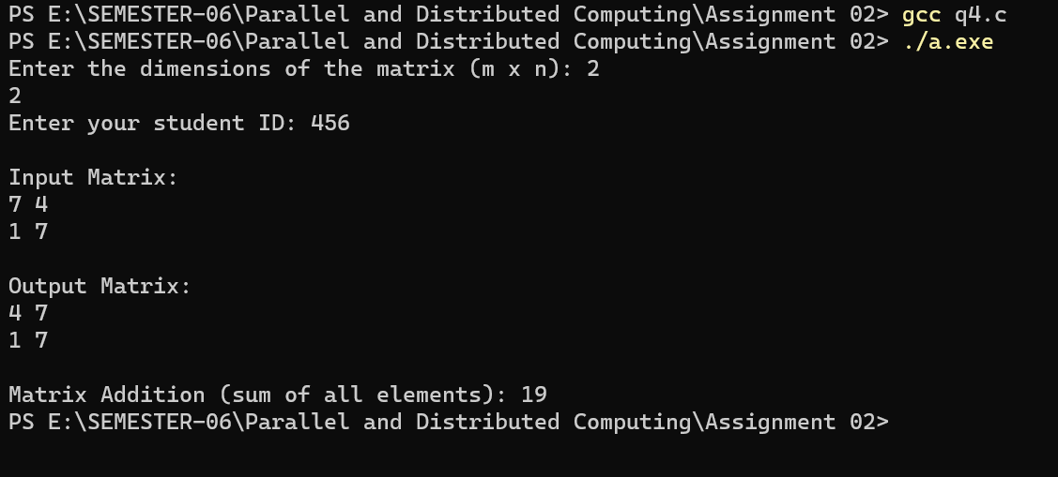

**Question 3:**



